From: https://marisol-nostromo.medium.com/neocon-to-english-dictionary-a3a4a88ec9b6
Title: Neocon to English dictionary
Author: Marisol Nostromo
Date: Feb 19
Length: 2 min read
See also: 20180913 What are the neocons, really ++++.htm

Neocon to English dictionary
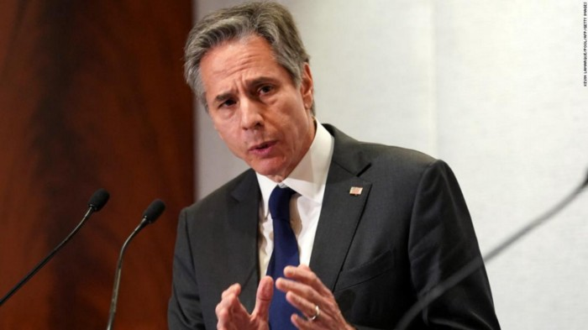
U.S. Secretary of State since Jan 26, 2021 Anthony Blinken
Given the pervasive influence of neoconservatives in academia, the media, and foreign policy establishments throughout the English-speaking world, Neoconese has become a sort of second language for people working in those professions. This has become a major source of confusion for laypersons, since many words in Neoconese have entirely different meanings in English. We provide here translations of some of the most common terms (we will be adding to this list over time):
- Authoritarian — a nation on the neocon “bad guys” list, i.e. a nation not aligned with the Anglophile bloc. See also Democracy
- Civil Society — plausibly deniable activities carried out by “Five Eyes” intelligence agencies (UK, US, Canada, Australia, New Zealand). This includes, for example, NGOs (Non-Governmental Organizations) and various forms of mercenary groups, especially those deployed for Color Revolutions and other forms of Regime Change operations.
- Democracy — a nation on the neocon “good guys” list, i.e. a nation aligned with the Anglophile bloc. See also Authoritarian. It is important to note that in Neoconese, “democracy” is not related to voting; voting is considered to be a problem because voters so often make inappropriate or malign choices.
- Human Rights — this term only comes into play with regard to nations that are classified as Authoritarian, and refers to any form of alleged oppression that may be used to justify economic sanctions and other forms of warfare. It is important to note that Democracies are free to violate human rights in the normal sense of the term; for example, Ukraine bans opposition media outlets and jails opposition candidates for treason, Colombia and Israel shoot non-violent demonstrators, and the UK imprisons and tortures inconvenient journalists.
- Malign —not pleasing to neocons.
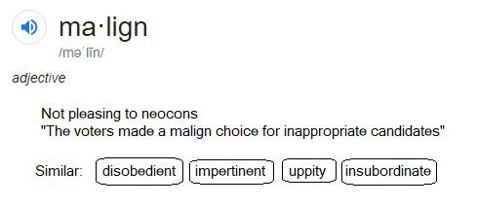
- Sovereignty — (untranslatable) There is no English language equivalent for the word “sovereignty” as used by the neocons.
- Sustainable — economic activity that is inherently incapable of leading a given nation toward industrialization and self-sufficiency. It is a vital concern with respect to keeping the nation in question as a repository of raw materials for Anglophile raw materials cartels.
4

